Capstone Project

**Superstore Sales Performance - Capstone Project**

After diving deep into the Superstore dataset, I’m thrilled to present my latest Tableau project focused on analysing and visualizing sales performance. This project not only challenged my skills but also provided valuable insights into sales dynamics.

Dashboard Highlights are:

View 1: Total Sales View 2: Total Profit

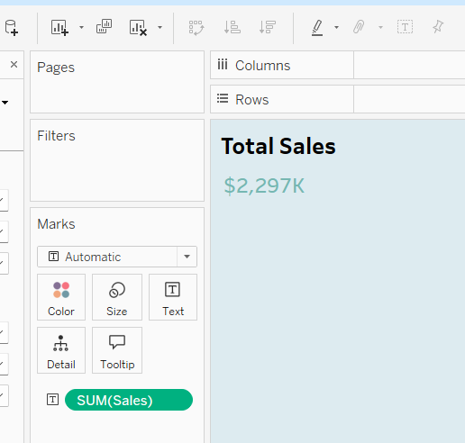 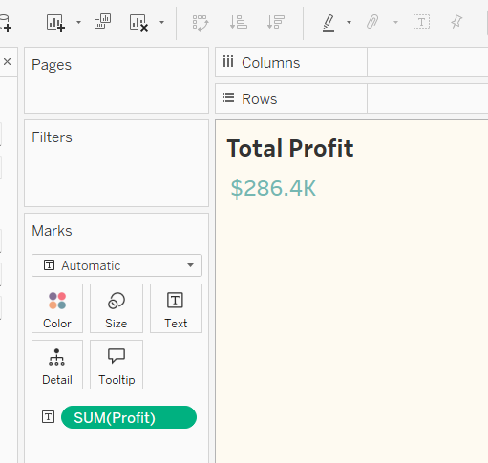

View 3: Total Volume View 4: Sales per customer

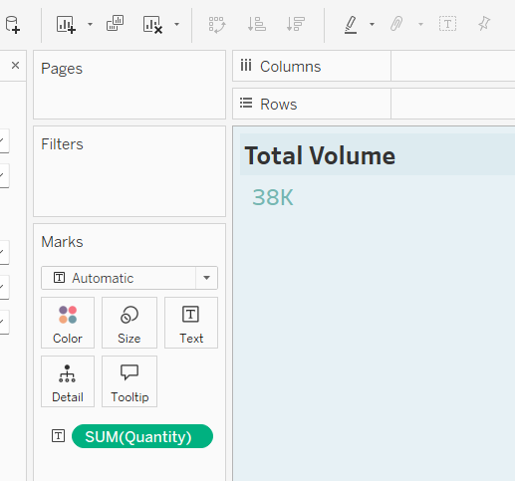 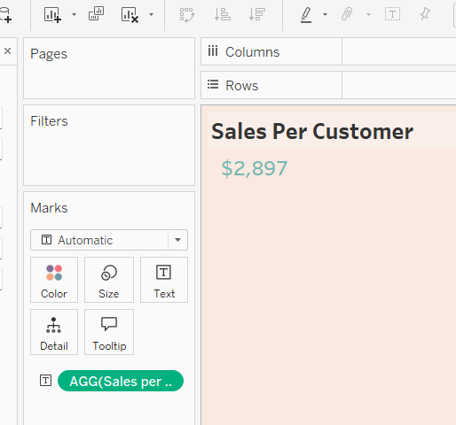

View 5: Pie Chart View 6: Bar Chart

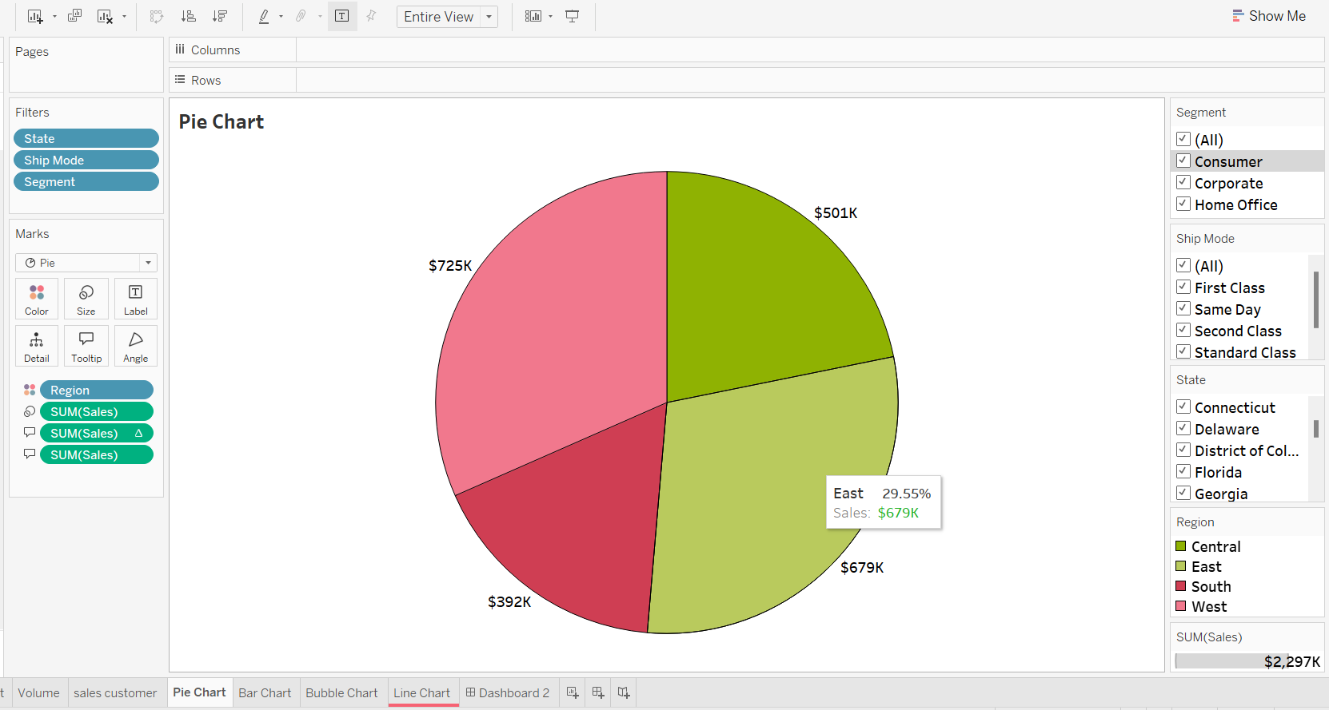 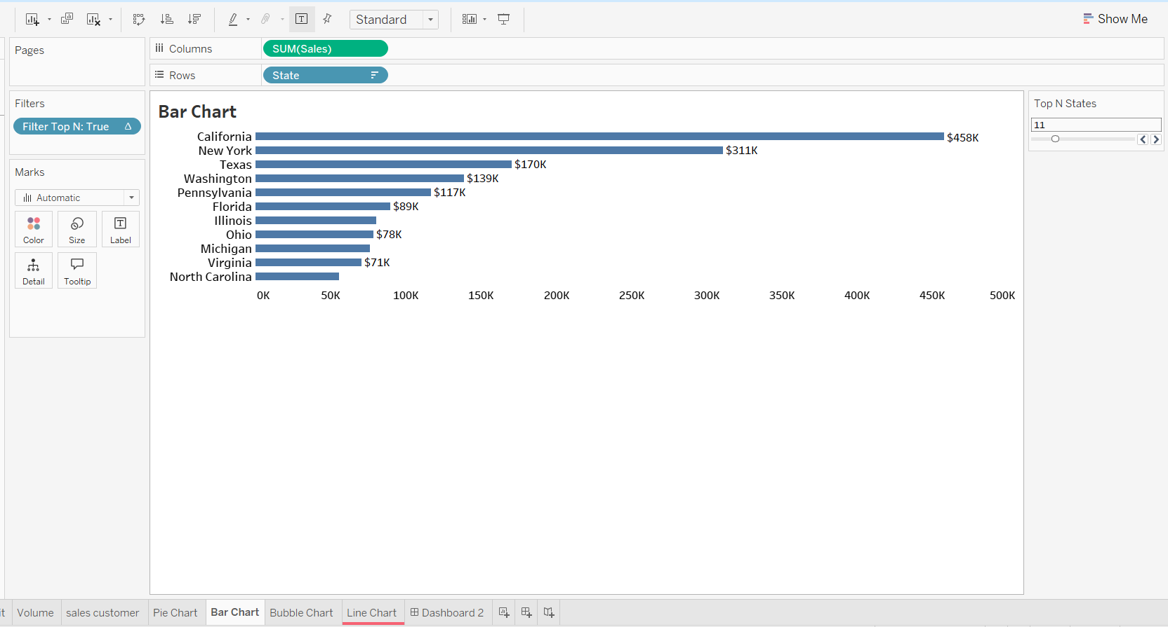

View 7: Bubble Chart View 8: Line Chart

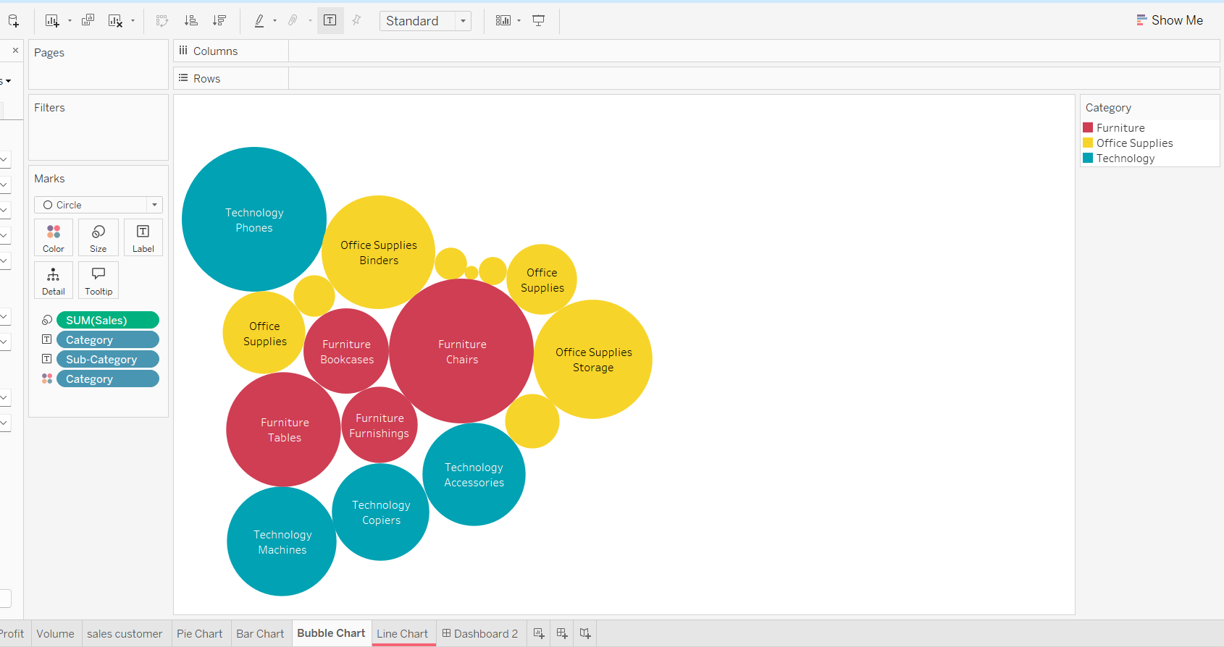 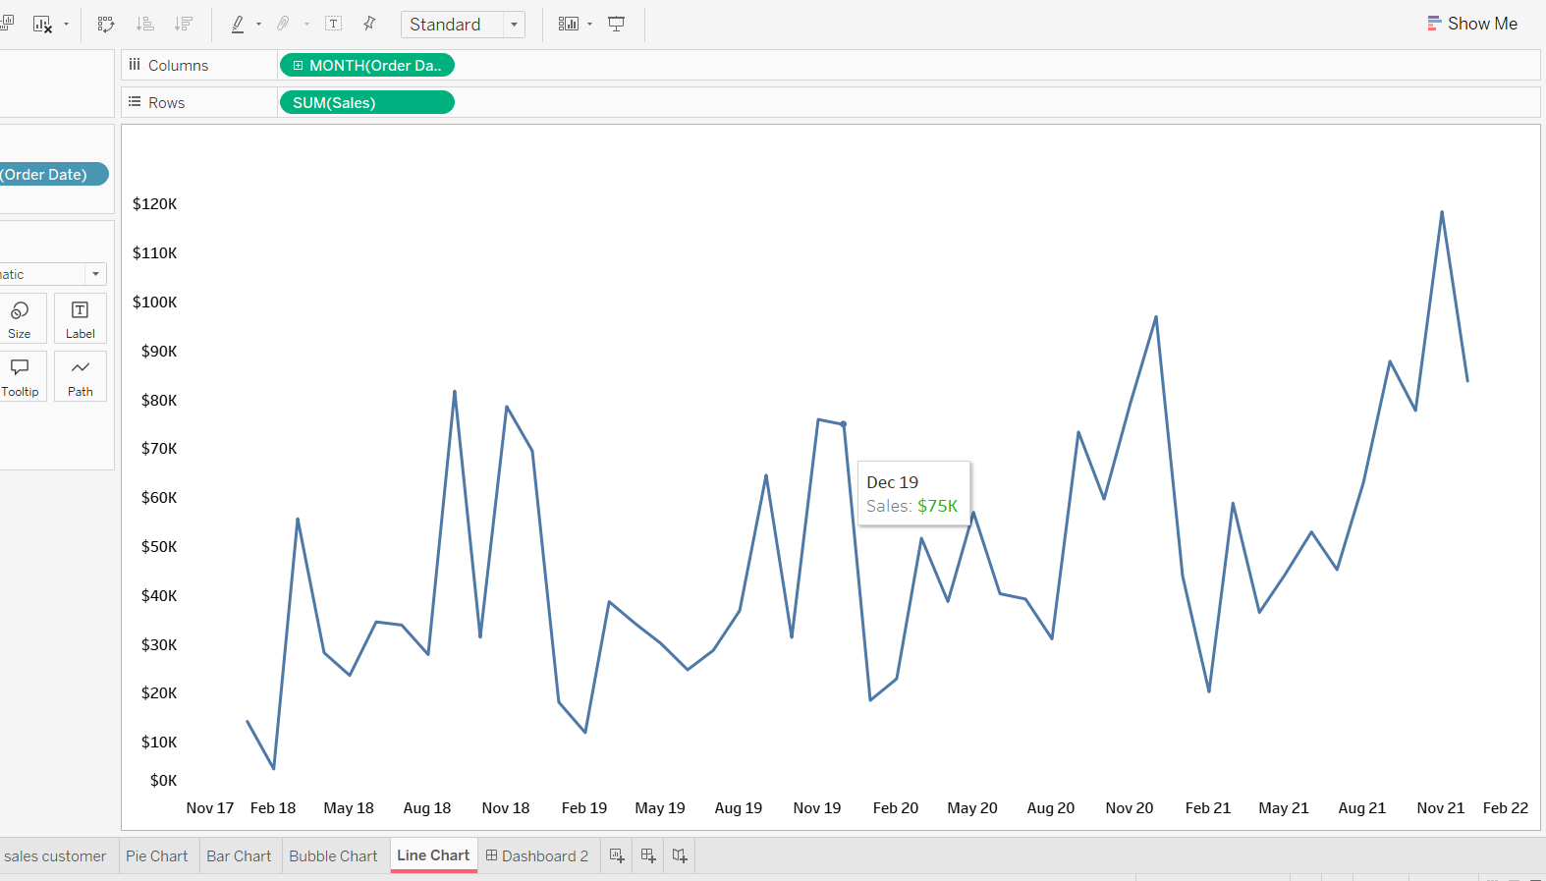

**The Dashboard:**

Created a comprehensive, single-dashboard solution to visualize sales data.  
Implemented a user-friendly interface with actionable filters and dynamic parameters.

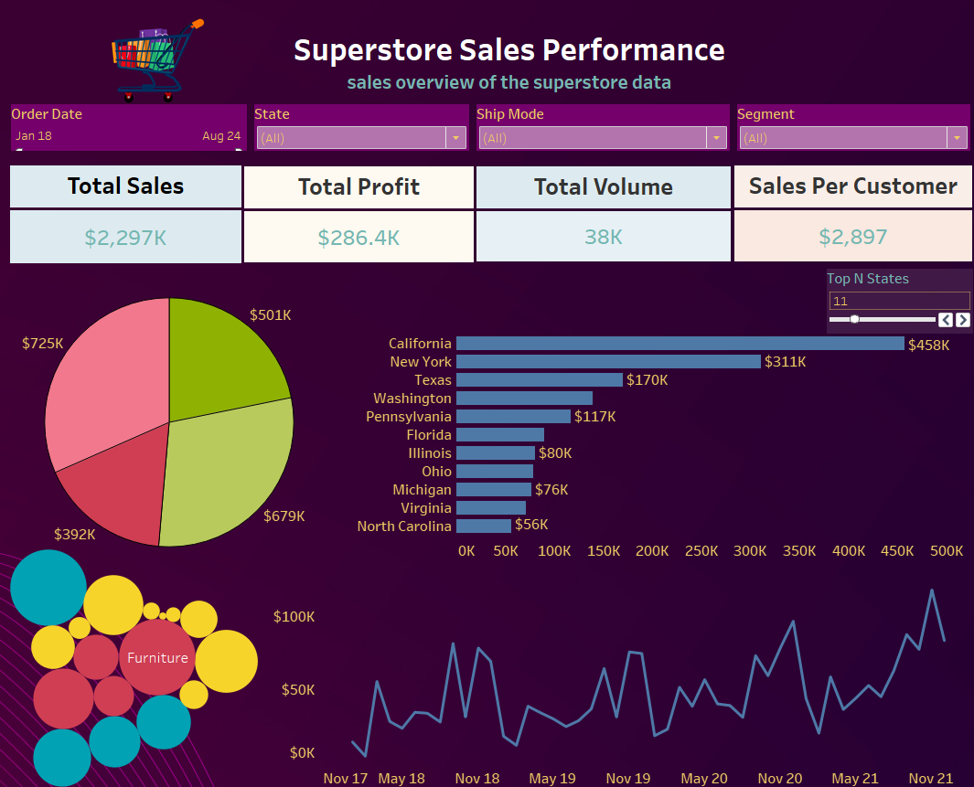

Here I’m sharing my tableau public link for this dashboard.

**🔗 Check out the full dashboard on Tableau Public:** https://public.tableau.com/views/Capstone2_17236578557560/Dashboard1?:language=en-US&publish=yes&:sid=&:redirect=auth&:display_count=n&:origin=viz_share_link